Laboratorio 3 FOOTPRINTING

**Definition of Footprinting:**

All the things that we create, search, share in internet have a respective trace, any person that know how search in internet can found this trace. The concept of Footprinting is :” the technique used for gathering information about computer systems and the entities they belong to”, only with the capacity of a web site like Google you can find a lot of vulnerabilities in a web site like: information of the data base, subdomain that have security problems, information of servers or simply information that no should not be available to everyone.

In this lab I has the mission to select a web site and search some vulnerabilities that can be exploited, in my case I select El Laboratio de La Escuela de Ingenieros with the help of Google advanced search and exploit google hacking data base the following information could be obtained:

1. **intitle:"password"  site:escuelaing.edu.co**.

This command redirects us to a page which provides the option to recover the lost password. Also brings an e-mail and the physics direction of the university. if we thing in a future attack we could clone this page and cheat the students and directive for obtain the user and the password.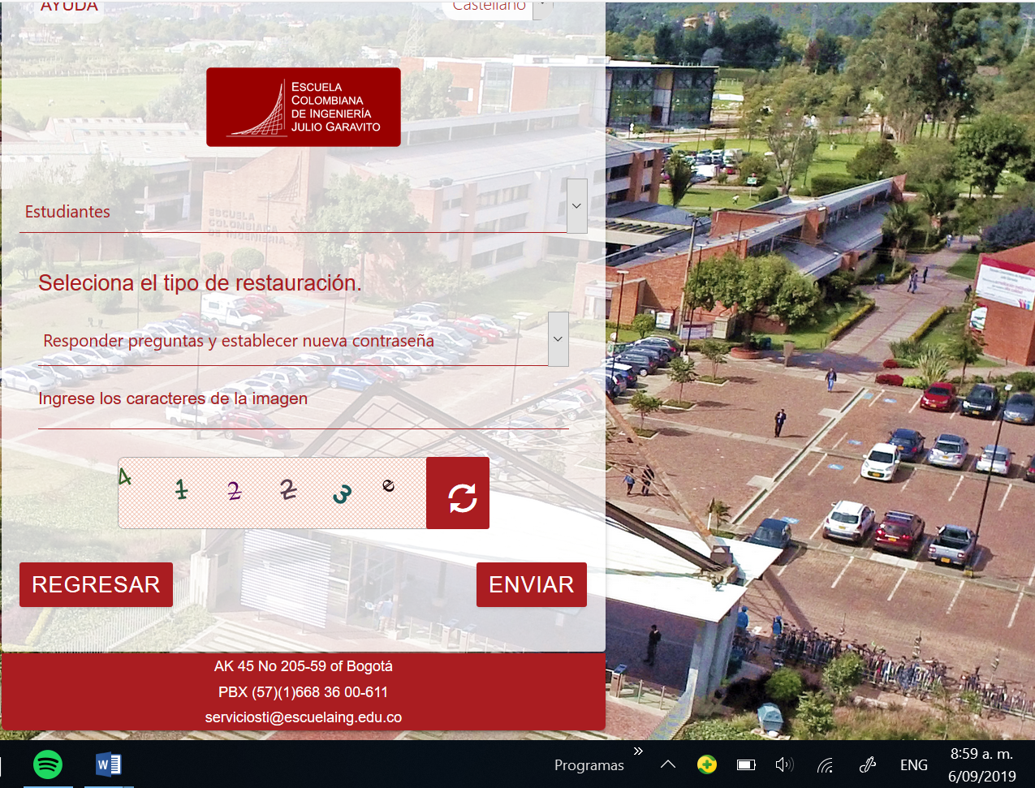

1. **intitle:" Admin"  site:escuelaing.edu.co**

Thiscommand directed us to a page that provides information about the laboratory, similar to the main page of the laboratory, with this information and doing a procedure similar to the previous one, we can obtain users and passwords of the users.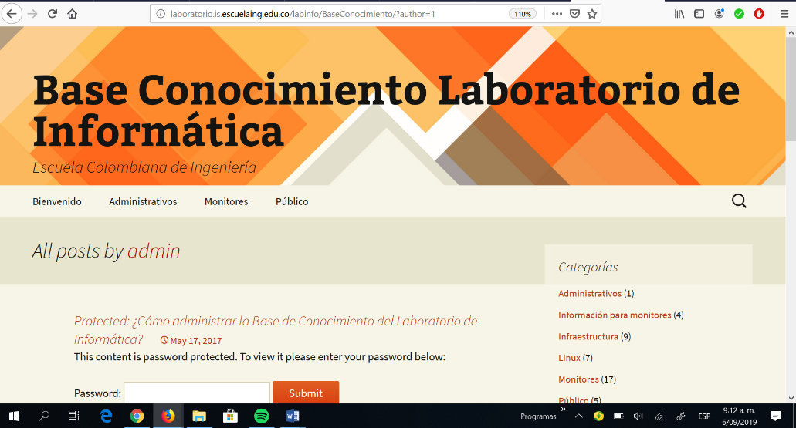

1. **intitle:"news" site:escuelaing.edu.co**

With this command a lot of important information was obtained some names of employs that which will be presented later and most importantly, we obtain information about the equipment they handle in the laboratory, their operating system, type of processor, network adapter, etc. With this information we can begin to plan an attack based on the operating system and the computing capacity that is handled.

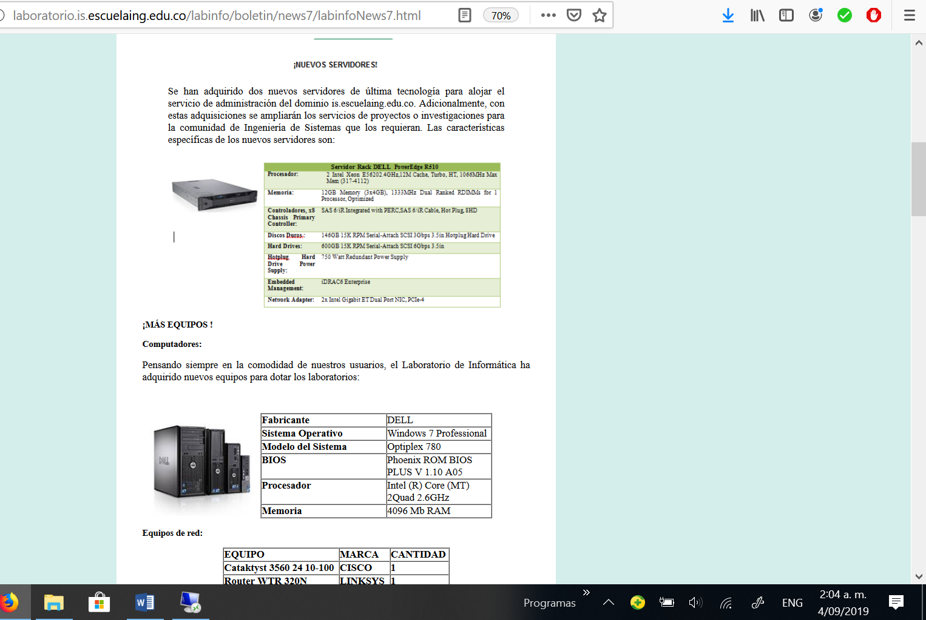

1. **intitle:"IIS Windows Server" -inurl:"IIS Windows Server" site:escuelaing.edu.co**

With this command we found a page that can confirm the school server of the university and an attack could be planned based on it.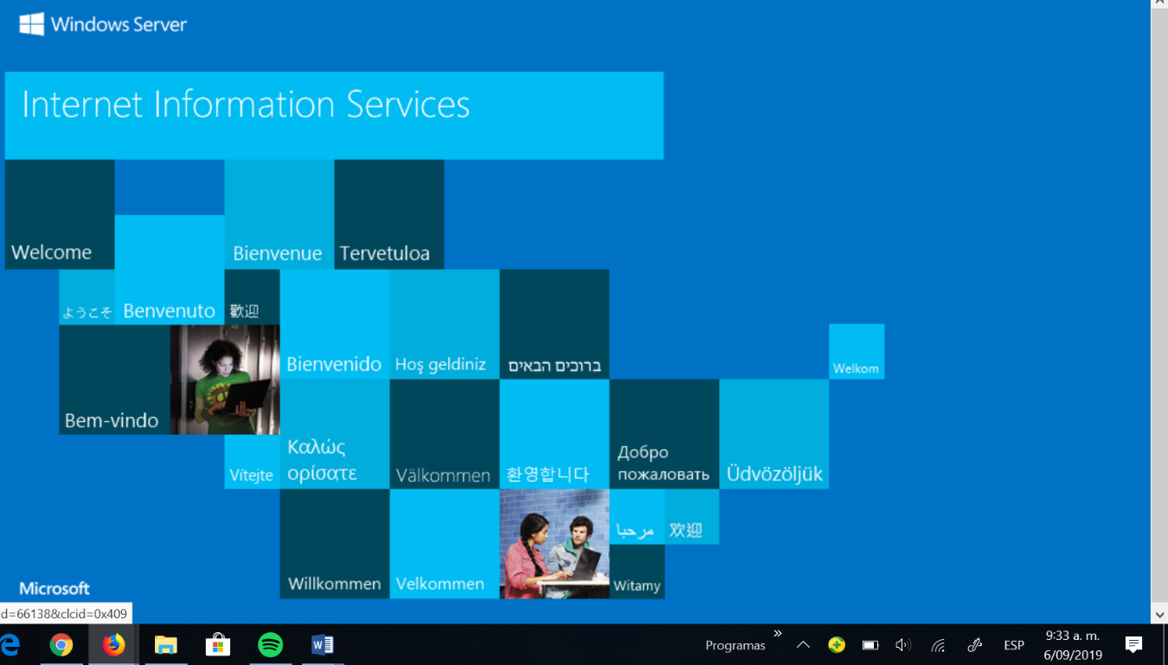

1. **intitle:"Index of /" site:escuelaing.edu.co**

With this command a file browser species was found, these files give us information about the server that was used, in addition to its versions.

With the parent director we can return to the directory and thus continue to obtain information about your files.

Despite the update date is information that should no longer be available and looking for a vulnerability can be found

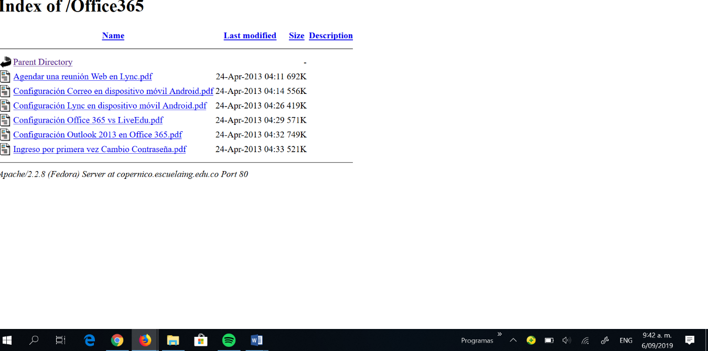

1. **intitle:"plugin" site :escuelaing.edu.co**

his query returns us a page witha directorysimilar to the previous one, however this page presents plugins that were obtained from the server, it gives us the possibility to browse the directory and copy all this information. In addition, .jar files were found which may have compilation instructions, executable files or metadata.

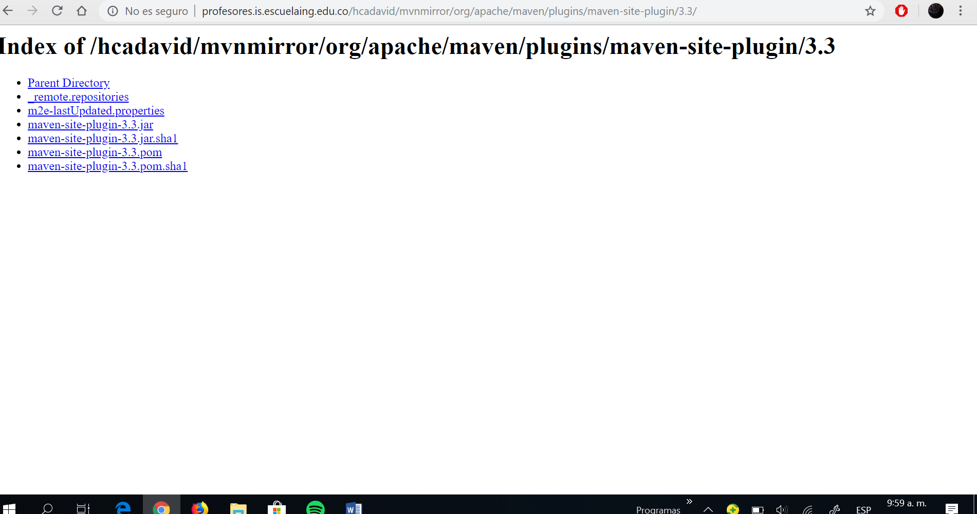

**Second part:**

In our search of look some information about the Escuela de ingenieros, we detect the three most important people In the management of the laboratory are: the engineer Claudia Patricia Santiago Cely, the technologist Alba Barbosa Triviño and the other tecnologist Aurora León Duarte.

Aurora Leon Duarte it’s the person that management the operative system Windows in the laboratory, she has the capacity to manage the data base, the publication in windows server and give support in installing programs

Alba Barbosa Triviño it’s the person that management the operative system Linux in the laboratory, she has the capacity to manage the data base, publication in the Linux server and bringth support in installing programs.

##### Claudia Patricia Santiago Cely is the director of the laboratory, she has multiple titles, is a engineer sistems, has an specialization In Software for Networks and a master in information management, in her jobs she worked in informatics security.

##### The last person that we found was the ex-student [Edward Mauricio Niño](https://www.facebook.com/edward.nino?__tn__=%2CdlC-R-R&eid=ARCQVbGPdvBZJlFF7yvu7LRTEIhOht3l42k8v3SMpuxMddJYs9OP59AZFQPp24KMue4UbCaYr-Ov3AgP&hc_ref=ARS13s7NKPpRXQM6knSuxdyT_wGCJx_mxHVNWfyoccj1Bu6E0xcT6ipNl8IJ3AdOLaM), in this moment in his linkedin account has the next information: “Experience in analysis and design of requirements, planning and implementation of projects in HFM in several business groups such as Carvajal, IMSA, Promigas”.

##### Importance of this information:

##### In our searching we found the most important people that manage the laboratory, if we want to make an attack it´s important to know that maybe Alba and Aurora don´t have the capacity to stop the attack, but Claudia have all the experience and studies to stop us, for this reason our best strategy to make an attack is to have an access her schedule and try the attack when she is not available. Maybe we can take this information with Edward, if he was a monitor, maybe he was a lot of time with Claudia a know her schedule.